
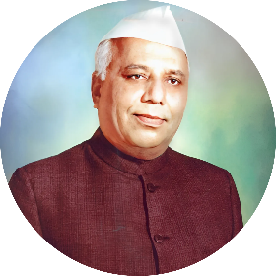
"Self-reliant education is our motto"
RAYAT SHIKSHAN SANTHA’S
YASHAWANTRAO CHAVHAN INSTITUTE OF SCIENCE SATARA
K.B.P.university satara

- DEPARTMENT OF STATISTICS

- A PROGRAM ON

- "Health Survey of School Students: Analysis of Nutrition and Physical Well-being."

Submitted To

- DEPARTMENT OF STATISTICS

In partial fulfillment for the award of the degree of

BACHELOR OF SCIENCE IN

DEPARTMENT OF STATISTICS (BSc.III)

2025-26 (Batch)

DECLARATION

Respected Sir / Madam,
I undersigned hereby declare that this project entitled “Health Survey of School Students: Analysis of Nutrition and Physical Well-being.” is conducted under the guidance of MR. K. A. Ghorapade sir this is our original work. The empirical finding in the report is based on the work conducted by us personally & is not reproduction of any source.
If our work is found to be copied, then we will be liable to be punished under the rule
Date: -
Place: - Satara
Submitted by :
Name of student: | Roll No : | Department : | Class :
- Gaurav Dadasaheb Mane | 321 | Statistics | BSC : III
- Sujit Ashok Pawar | 330 | Statistics | BSC : III
- Abhishek Adhik Pawar | 324 | Statistics | BSC : III
- Tanishq Tushar More | 322 | Statistics | BSC : III
- Yash Vinod Shirke | 335 | Statistics | BSC : III
- Sushant Santosh Shendge | 333 | Statistics | BSC : III

ACKNOWLEGEMENT

This report has been made through direct & indirect cooperation of various person for whom we wish to express our appreciation & gratitude.
We are very thankful to MR. K. A. Ghorapade sir for guiding throughout our project & exceeding useful cooperation during the period with discussion & guidance to success our project works.
Words are insufficient to express our appreciation for the valuable advice & continuous motivation provided by BSc. Department Statistics of YASHAWANTRAO CHAVHAN INSTITUTE OF SCIENCE, SATARA (Autonomous)
We take this opportunity to express our deep gratitude to Mr. (Head Dept. of Statistics).
DR. H. P. UMAP SIR
INDEX

S.R NO | CONTENTS | Page no.
1 | INTRODUCTION
2 | OBJECTIVES
3 | COLLECTION OF DATA
4 | STATISTICAL TOOLS USED FOR ANALYSIS
5 | TECHNIQUES
6 | DIAGRAMMATIC REPRESENTATION OF DATA
7 | STATISTICAL ANALYSIS OF DATA
8 | CONCLUSIONS
9 | REFERENCE
10 | QUESTIONARIE

INTRODUCTION OF PROJECT

This project, titled “Health Survey of School Students: Analysis of Nutrition and Physical Well-being”, has been conducted at Z. P. Primary School, Golibar Maidan.
The purpose of this study is to understand the health, nutrition, and lifestyle patterns of school students. Children’s physical and mental growth depends largely on their daily diet, sleep, water intake, and physical activity. In today’s world, many students face health challenges due to irregular eating habits, lack of balanced nutrition, insufficient exercise, and disturbed sleep schedules.
Through this survey, data was collected on important health factors such as height, weight, Body Mass Index (BMI), protein intake, carbohydrate intake, water consumption, sleep pattern, frequency of illness, and physical activity. By analyzing these parameters, we aim to identify common health issues among students and provide suggestions to improve their overall well-being.
This project will also help create awareness among students, teachers, and parents about the importance of proper nutrition, regular exercise, and healthy lifestyle habits. The expected outcome of this survey is to highlight the relationship between food, health, and physical fitness, and to encourage healthier choices for a better future.

OBJECTIVES

- The main objectives of the project “Health Survey of School Students: Analysis of Nutrition and Physical Well-being” conducted at Z. P. Primary School, Golibar Maidan are as follows:
- To collect health-related data from school students including height, weight, BMI, and other nutritional factors.
- To study the dietary habits of students, focusing on protein intake, carbohydrate intake, and daily water consumption.
- To analyze lifestyle patterns such as sleep duration, quality of sleep, physical activity, and frequency of illness.
- To examine the relationship between students’ nutrition, physical fitness, and overall health.
- To identify gaps or deficiencies in students’ diet and daily routines that may affect their health.
- To provide practical suggestions and awareness to improve the nutritional habits and physical well-being of students.

COLLECTION OF DATA

- For this project, data was collected from the students of Z. P. Primary School, Golibar Maidan. The process of data collection was carried out in a systematic and organized manner to ensure accuracy and reliability.
- Personal Interaction:
Each student from different classes was personally approached and asked relevant questions regarding their daily routine, eating habits, sleep pattern, and physical activity.
- Measurements Taken:
Important health parameters such as height, weight, and Body Mass Index (BMI) were measured for each student. These measurements were noted carefully to analyze the growth and physical well-being of the students.
- Questionnaire Method:
A structured set of questions was prepared and students were asked about their dietary intake (proteins, carbohydrates, water intake), sleep duration, frequency of illness, and involvement in sports or physical activity.
- Google Form Submission:
To make the process easier and organized, all responses from the students were recorded using Google Forms. This helped in storing the data digitally for further analysis and ensured that no details were missed.
- Observation:
Along with direct responses, observations about students’ behavior, physical fitness, and attentiveness in school were also noted to support the collected data.
- Teacher & Parent Insights (Additional):
To make the data more accurate, inputs from teachers and, in some cases, parents were also considered regarding the health and lifestyle of the students.
- Through this systematic process, reliable and useful data was gathered which forms the basis for further analysis and conclusions in this project.

Statistical tools used for analysis

- For the project “Health Survey of School Students: Analysis of Nutrition and Physical Well-being” conducted at Z. P. Primary School, Golibar Maidan, various statistical tools have been used to analyze the collected data. These tools help in organizing, interpreting, and drawing meaningful conclusions.
The following statistical methods were applied:
- Mean (Average):
To calculate the average of health parameters such as height, weight, BMI, and sleep hours.
- Median and Mode:
To understand the central tendency of data and identify common values among the students.
- Percentage Analysis:
To represent the proportion of students with specific dietary habits, illness frequency, or activity levels.
- Standard Deviation and Variance:
To measure the spread and variability of data related to students’ health and nutrition.
- Correlation Analysis:
To study the relationship between two variables, such as nutrition and BMI, sleep and health, or water intake and frequency of illness.
- Chi-Square Test (if applicable):
To test the association between categorical variables like eating habits and health conditions.
- Graphical Representation:
Data has been presented using bar charts, pie charts, and histograms for easy understanding and visual interpretation.
- Hypothesis Testing:
To verify whether assumptions (e.g., “There is a relationship between nutrition and physical well-being”) hold true based on the data collected.

TECHNIQUES

- For the project “Health Survey of School Students: Analysis of Nutrition and Physical Well-being” conducted at Z. P. Primary School, Golibar Maidan, the following techniques were adopted to ensure accurate data collection and meaningful analysis:
- Survey Technique:
A structured survey method was used where students were asked direct questions about their nutrition, lifestyle, and health habits.
- Interview Technique:
Personal interactions were conducted with students to gather additional details and to clarify responses.
- Measurement Technique:
Physical measurements such as height, weight, and BMI were taken using standard measuring instruments to ensure accuracy.
- Questionnaire Technique (Google Form):
A set of well-structured questions was designed and responses were collected digitally through Google Forms, making the process systematic and error-free.
- Observation Technique:
Students’ physical appearance, activity levels, and attentiveness in school were also observed to support and validate the collected data.
- Secondary Information (if required):
Reference materials from health and nutrition guidelines were used to compare the collected data with standard values.
These techniques together ensured that the project was based on both quantitative data (measurements, calculations) and qualitative data (observations, responses).

DIAGRAMMATIC REPRESENTION OF DATA

- "Class-wise Gender Distribution of Students (1st to 7th Std)"

- Interpretation:
- The chart shows the number of boys and girls in each class from 1st to 7th standard.
- In most classes, the number of boys is slightly higher than the number of girls.
- The 6th standard has the highest number of boys (16) compared to girls (3).
- The distribution indicates that boys are consistently more in number across classes, while the number of girls remains comparatively lower.

- "Breakfast Food Preferences of Students"

- Interpretation:
- The chart shows the types of food items most commonly eaten by students for breakfast.
- Poha is the most preferred breakfast item with 29 boys and 8 girls consuming it.
- The second most common choice is Chapati with vegetables (16 boys, 23 girls).
- Other items like eggs and miscellaneous foods are chosen rarely.
- This indicates that Poha and Chapati with vegetables are the two dominant breakfast foods among the students.

- "Daily Milk Consumption among Students"

Interpretation:
- The chart shows the number of students (class-wise) who drink milk every day versus those who do not.
- Majority of students in all classes drink milk daily.
- Very few students answered No, which means milk is a regular part of the diet for most children.
- Highest number of milk consumers are seen in 6th and 7th standard students.

- Frequency of Eating Eggs/Fish/Meat among Students

- Interpretation:

- The chart shows how often students consume eggs, fish, or meat.
- 41 students eat non-veg foods 2–3 times a month, which is the largest group.
- 26 students consume them rarely, showing a lower preference or availability.
- 6 students reported eating them every day, indicating high protein intake.
- 13 students said they never eat eggs/fish/meat, possibly due to vegetarian diet or family restrictions.
- 6 students fall into the “Other/less frequent” category.

- Consumption of Green Leafy Vegetables/Grains in Daily Diet

- Interpretation:
The chart shows how frequently students from 1st to 7th standard include green leafy vegetables or grains in their diet.
- A majority of students sometimes eat green leafy vegetables/grains rather than daily.
- Only a few students (very small count) reported that they always include them in their diet.
- Very few responses fall under the rarely category, but still it highlights that not all students get regular vegetable intake.
- The trend across classes (1st to 7th) indicates that irregular consumption is common in all standards, showing a need for improvement in awareness about healthy eating habits.
- This suggests that while students do consume leafy vegetables and grains, their intake is not consistent on a daily basis, which may impact their nutritional balance and overall health.

- Daily Water Drinking Habits among Students (by Gender)

- Interpretation:
The graph shows how many glasses of water students (boys and girls) drink per day.
- The highest number of students (25) drink 5–6 glasses of water daily, which is a healthy habit.
- 20 students drink only 1–4 glasses, indicating insufficient water intake.
- 17 students consume 7–8 glasses daily, showing good hydration habits.
- A smaller group (11 students) drink more than 8 glasses a day, which is above average.
- The lowest group (3 students) drink 0 glasses, which is concerning for health.
- Boys and girls show almost similar patterns in water consumption with slight variations.
- Overall, most students drink 5–6 glasses of water daily, but a considerable number still drink less than the required amount, which may affect their health and hydration.

- Frequency of Illness (Cold, Cough, Fever) among Students in the Last 6 Months

- Interpretation:
The chart presents how often students from 1st to 7th standard have suffered from illnesses such as cold, cough, and fever in the last six months.
- The highest number of students reported illness “sometimes”, showing that occasional health issues are common.
- A significant portion of students mentioned they rarely fall sick.
- A smaller group of students reported frequent illness, which may indicate weaker immunity or poor nutrition.
- Some students answered “No, it didn’t happen”, which reflects a comparatively healthier group.
- The distribution across different classes shows that sickness is observed in almost all standards, with varying intensity.
- Overall, the data indicates that occasional sickness (sometimes) is most common among students, while frequent illness is less common but still present. This suggests the need for better nutrition, hygiene, and preventive healthcare to reduce illness frequency among school children.
- “Types of Food Available at School”

- Interpretation:
- The chart shows that Chikki (35) is the most commonly available food at school, followed by Ragi Ladu (24).
- Fruits (10) and Rice (3) are available in smaller quantities.
- Chocolate (1) is the least available item, indicating that junk or fast food items are less provided.
- Overall, the school mainly provides traditional and healthy food items like Chikki and Ragi Ladu, which are nutritious compared to chocolates or junk food.

- Time Spent by Students Playing at School/at Home Every Day

- Interpretation:
The chart shows how much time students spend daily on play activities either at school or at home.
- The largest group (25 students) spends 30 minutes to 1 hour playing daily.
- 23 students play for less than 30 minutes, which is quite low for their age group.
- 21 students play for more than 1 hour, showing that a good portion of students get sufficient physical activity.
- A small group (7 students) reported very little playtime, which is concerning for their physical and mental health.
- Both boys and girls show almost similar patterns of playtime with slight variations.
- Conclusion:
Most students get 30 minutes to 1 hour of daily playtime, which is a healthy habit, but a notable number of students spend very little time in play. Since play is important for growth, fitness, and mental well-being, schools and parents should encourage children to engage in more physical activities rather than limiting their playtime.

- Daily Sleeping Hours of Students

- Interpretation:
The chart shows the sleeping patterns of students.
- 46 students (54%) sleep for more than 9 hours daily, which is good for proper rest and growth.
- 37 students (43%) get 6–8 hours of sleep, which is average but slightly less than recommended for children.
- Only 3 students (3%) reported sleeping less than 5 hours, which is very low and can negatively affect health, concentration, and immunity.
- Conclusion:
Most students are getting adequate or more than sufficient sleep. However, a small group with very less sleep needs attention, as proper sleep is essential for children’s physical growth, learning ability, and overall health.

- “Nutritional Status of School Students (Based on BMI)”
Height (cm) | Weight (kg) | Class | Nameame | BMI | BMI Result
123 | 21 | 1st | Ishwari Somnath Shirasagar | 13.88 | Underweight
112 | 17 | 1st | Anushka Anil Kamble | 13.55 | Underweight
109 | 15 | 1st | Devansh Avinash Sule | 12.63 | Underweight
113 | 17 | 1st | Amber Vitthal Lava | 13.31 | Underweight
120 | 17 | 1st | Saanvi Navnath Chavan | 11.81 | Underweight
113 | 18 | 1st | Aslesh Arvind Vaidande | 14.10 | Underweight
116 | 14 | 1st | Janhvi Anup Kamble | 10.40 | Underweight
101 | 13 | 1st | Nature Nitin Kengar | 12.74 | Underweight
106 | 14 | 1st | Tejas Bhasuraj Madar | 12.46 | Underweight
112 | 15 | 1st | Anu Ramesh Kumar | 11.96 | Underweight
109 | 17 | 1st | Rayesh Ramzan Shaikh | 14.31 | Underweight
117 | 17 | 1st | Aditya Kumar Patil | 12.42 | Underweight
117 | 16 | 2nd | Arpita Rajput | 11.69 | Underweight
125 | 20 | 2nd | Shivansh Vinod More | 12.80 | Underweight
119 | 19 | 2nd | Kurtika khajjappa dandul | 13.42 | Underweight
115 | 17 | 2nd | Naira to Praveen One | 12.85 | Underweight
115 | 16 | 2nd | Prem Nitin Kengale | 12.10 | Underweight
124 | 22 | 2nd | Tanvi Dattatreya Raut | 14.31 | Underweight
117 | 18 | 2nd | Atharva Bhanudas Nalawade | 13.15 | Underweight
117 | 18 | 2nd | Climber Anil Kamble | 13.15 | Underweight
125 | 18 | 3rd | Swaranjali Amol Paret | 11.52 | Underweight
133 | 30 | 3rd | Shreyas Anandrao Jadhav | 16.96 | Underweight
126 | 18 | 3rd | Prasad Manik Mane | 11.34 | Underweight
128 | 23 | 3rd | Shravan Mangesh Chinkate | 14.04 | Underweight
126 | 22 | 3rd | Manaswi Suresh Kadam | 13.86 | Underweight
123 | 22 | 3rd | Zoya Ramadan Sheikh | 14.54 | Underweight
132 | 24 | 3rd | Jai Vikram Shinde | 13.77 | Underweight
130 | 22 | 3rd | Shaurya Yogesh Sathe | 13.02 | Underweight
129 | 21 | 3rd | Siddhnath Bhairav Natekar | 12.62 | Underweight
129 | 23 | 3rd | Vedanta Mahesh Jagtap | 13.82 | Underweight
121 | 21 | 3rd | Novel Basaveshwar Lohar | 14.34 | Underweight
119 | 17 | 3rd | Suman Rajeev Bawari | 12.00 | Underweight
132 | 28 | 3rd | Priya Nitin Chavan | 16.07 | Underweight
119 | 17 | 3rd | Shreya Sagar Yadav | 12.00 | Underweight
132 | 37 | 3rd | Harshvardhan Amol Nikalje | 21.24 | Normal weight
130 | 24 | 4th | Nandini Kumar Patil | 14.20 | Underweight
130 | 24 | 4th | Mr. Mahesh Jabalkar | 14.20 | Underweight
134 | 27 | 4th | Prithvi Nitin Kengar | 15.04 | Underweight
127 | 19 | 4th | Adishri Sriram said | 11.78 | Underweight
141 | 27 | 4th | Omkar Manoj Dangre | 13.58 | Underweight
137 | 24 | 4th | Sanvi Sanjay Deshmukh | 12.79 | Underweight
135 | 24 | 4th | Shivanand Sharanopa Beknal | 13.17 | Underweight
121 | 19 | 4th | Tara Basuraj Madar | 12.98 | Underweight
135 | 29 | 4th | Anushka Vinod More | 15.91 | Underweight
132 | 27 | 4th | Mohini Vishal Pawar | 15.50 | Underweight
128 | 23 | 4th | Geeta Ravi Chavan | 14.04 | Underweight
142 | 34 | 4th | Rohit Dilip Jadhav | 16.86 | Underweight
145 | 37 | 4th | Prashant Kiran Chavan | 17.60 | Underweight
150 | 33 | 5th | Piyush Pandurang Jadhav | 14.67 | Underweight
141 | 29 | 5th | Verse Kiran Kesarkar | 14.59 | Underweight
132 | 28 | 5th | Rudra Dattatreya Raut | 16.07 | Underweight
135 | 22 | 5th | Akshay Sadanand Agsar | 12.07 | Underweight
146 | 37 | 5th | Vedanta Bhairav Natekar | 17.36 | Underweight
137 | 24 | 5th | Vignesh Umesh Awkhe | 12.79 | Underweight
125 | 21 | 5th | Shriram Sandeep Bartakke | 13.44 | Underweight
132 | 22 | 5th | Sarthak Amol Paret | 12.63 | Underweight
136 | 36 | 5th | Kavya Suresh Kadam | 19.46 | Normal weight
137 | 32 | 5th | Aditya Rajendra Raut | 17.05 | Underweight
146 | 39 | 5th | Sharanya Nanasaheb Bhosale | 18.30 | Underweight
132 | 26 | 5th | Viraj Kiran Kamble | 14.92 | Underweight
126 | 20 | 5th | Shreyas Ramdas Nalawade | 12.60 | Underweight
132 | 22 | 5th | Govind Dharu Nath Yogi | 12.63 | Underweight
143 | 49 | 5th | Aditya Ajit Uttekar | 23.96 | Normal weight
146 | 41 | 5th | Shivam cuts the curb | 19.23 | Normal weight
150 | 29 | 5th | Avinash Anil Kamble | 12.89 | Underweight
149 | 43 | 5th | Sharyu Prakash Katwate | 19.37 | Normal weight
143 | 38 | 5th | Love Abhijit Chavan | 18.58 | Normal weight
142 | 32 | 6th | Subhan Razak Shaikh | 15.87 | Underweight
138 | 26 | 6th | Shivam Ram Pravesh Chaudhary | 13.65 | Underweight
140 | 43 | 6th | Mahesh Basaveshwar Blacksmith | 21.94 | Normal weight
138 | 24 | 6th | Arush Vikram Aaake | 12.60 | Underweight
145 | 28 | 6th | Manodeep Manoj Gaikwad | 13.32 | Underweight
157 | 40 | 6th | Shrikesh Sanjay Jagtap | 16.23 | Underweight
139 | 33 | 6th | Aditya Vijay Pawar | 17.08 | Underweight
127 | 22 | 6th | Gauri Niwas Pawar | 13.64 | Underweight
142 | 37 | 6th | Pooja Santosh Salunkhe | 18.35 | Underweight
129 | 24 | 6th | Sanam Dilla knowing | 14.42 | Underweight
152 | 35.5 | 7th | Sheetal Ramesh Kamble | 15.37 | Underweight
159 | 41 | 7th | Sadia Altaf Shaikh | 16.22 | Underweight
139 | 31 | 7th | Payal Dattatreya Bubbles | 16.04 | Underweight
149 | 39 | 7th | Vedika Vijay Pandehra | 17.57 | Underweight
143 | 29 | 7th | Shraddha Bhanudas Nalawade | 14.18 | Underweight
151 | 41 | 7th | Atish Kiran Kamble | 17.98 | Underweight
136 | 23 | 7th | Pawan Raju Bawari | 12.44 | Underweight
146 | 32 | 7th | Shivani Ravi Chavan | 15.01 | Underweight
135 | 29 | 7th | Success Sanjay Kamble | 15.91 | Underweight

- Interpretation:
- High proportion of Underweight students
  - The table clearly shows that most of the students fall under the “Underweight” category.
  - This indicates a lack of proper nutrition in their daily diet.
- Few students with Normal weight
  - Only a small number of students, especially in 3rd, 5th, and 6th standards, are in the “Normal weight” category.
  - This suggests that only a limited group is receiving a balanced diet.
- No cases of Overweight or Obesity
  - The data does not show any student in the “Overweight” or “Obese” category.
  - This means fast food consumption is not very high, but nutritional deficiency is a concern.
Conclusion:
The data highlights that underweight is a major concern among the students. There is a strong need to improve their diet quality by including more fruits, vegetables, proteins, and other nutrient-rich foods. Schools and parents should work together to organize Nutrition Awareness Programs to promote healthy eating habits.

Data Analysis

- Descriptive statistics
- Sample: 86 students .
- Overall BMI:
- mean 14.61
- median 13.96
- SD 2.55 (BMI range 10.40 – 23.96).
- BMI categories:
- 79 (91.86%) Underweight
- 7 (8.14%) Normal weight.

- Significant relations found:
- Playtime and BMI — small but statistically significant difference between playtime groups (Kruskal-Wallis p = 0.049). More playtime → higher mean BMI.
- Green leafy vegetable intake and BMI — significant difference between “Always” vs “Sometimes” groups (Kruskal-Wallis p = 0.013).
- No significant relations: gender vs BMI category (Chi-square p = 0.684), milk daily vs BMI (Mann-Whitney p = 0.976), eggs/fish/meat frequency (p ≈ 0.793), sleep groups (p ≈ 0.970).
- Correlations: BMI strongly correlated with weight (r = 0.891, p < 0.001) and moderately with height (r = 0.566, p < 0.001) — expected because BMI uses weight and height.
2. Data Summary
- Table showing descriptive statistics (Mean, Median, SD for Height, Weight, BMI)
- Formula examples:
  - Mean = Σxi / N
  - Standard Deviation (SD) = √(Σ(xi − mean)² / N)
3. Statistical Analysis
(a) Relation 1: BMI vs Class
- Compute mean BMI per class
- Show table + bar chart
- Formula used:
  - BMI = Weight (kg) / (Height (m))²
- Interpretation
(b) Relation 2: Sleep vs BMI
- Cross-tabulation (Sleep categories vs BMI Result)
- Chi-Square test calculation
- Formula:
  - χ² = Σ (Oi − Ei)² / Ei
(c) Relation 3: Playtime vs BMI
- Kruskal-Wallis / Correlation
- Formula:
  - r = Σ(xi − x̄)(yi − ȳ) / √(Σ(xi − x̄)² Σ(yi − ȳ)²)
(d) Relation 4: Food Habits vs BMI
- Cross table: “Green Vegetables / Milk / Eggs” vs BMI Result
- Chi-Square analysis
(e) Relation 5: Height & Weight vs BMI
- Scatter plot & correlation
- Formula:
- Correlation coefficient (r)
- This report presents a detailed statistical analysis of students' health and nutrition survey data from Class 1 to Class 7. The dataset includes height, weight, BMI, sleep, playtime, and dietary habits. The aim is to identify factors affecting BMI and nutritional status.

Descriptive statistics (mean, median, standard deviation) provide a summary of the dataset.
Statistic | Height (cm) | Weight (kg) | BMI
count | 86.0 | 86.0 | 86.0
mean | 131.23 | 25.84 | 14.61
std | 12.4 | 8.32 | 2.55
min | 101.0 | 13.0 | 10.4
25% | 123.0 | 19.0 | 12.79
50% | 132.0 | 24.0 | 13.96
75% | 140.75 | 31.75 | 16.01
max | 159.0 | 49.0 | 23.96
Formulas Used:
- Mean = Σx / N
- Standard Deviation = √(Σ(x − mean)² / N)
3. Statistical Analysis
- Relation 1: BMI vs Class
Class
1st 12.80
2nd 12.93
3rd 14.08
4th 14.43
5th 15.93
6th 15.71
7th 15.64
Formula: BMI = Weight (kg) / (Height (m))²
Interpretation: BMI gradually increases from 12.8 in 1st Std to around 15.9 in 5th–7th Std, showing growth with age, but still mostly below the healthy range.
- Relation 2: Sleep vs BMI
Sleep Hours (oi) | Normal(oi) | Underweight(oi)
6–8 hrs | 2 | 35
<5 hrs | 1 | 2
>9 hrs | 4 | 42
Expected Table (Ei):
Sleep Hours(Ei) | Normal(Ei) | Underweight(Ei)
6–8 hrs | 3.01 | 33.99
<5 hrs | 0.24 | 2.76
>9 hrs | 3.74 | 42.26

Formula: χ² = Σ (Oi − Ei)² / Ei
Chi² = 2.94, df = 2, p = 0.23
P=0.23 > 0.05
- Interpretation: No significant relation between sleep duration and BMI result (p > 0.05).
- Relation 3: Food Habits (Green Vegetables) vs BMI Result
Observed Table (Oi):
Eat Greens Daily | Normal | Underweight
No | 3 | 17
Yes | 4 | 62
Expected Table (Ei):
Eat Greens Daily | Normal | Underweight
No | 1.63 | 18.37
Yes | 5.37 | 60.63
Chi² = 0.66, df = 1, p = 0.416
P= 0.416 > 0.05
- Interpretation:
- Students eating green leafy vegetables daily are not significantly more likely to have normal BMI (p > 0.05).
- However, slightly more Normal BMI cases are in the “Yes” group (4 vs expected 5.37), showing a mild positive effect.

- Relation 4: Correlation of BMI with Height & Weight
Relation | r-value
Height ↔ Weight | 0.87
Weight ↔ BMI | 0.89
Height ↔ BMI | 0.57

Correlation (BMI vs Weight): r = 0.891, p < 0.001
Correlation (BMI vs Height): r = 0.566, p < 0.001
Formula: r = Σ(x − x̄)(y − ȳ) / √(Σ(x − x̄)² Σ(y − ȳ)²)
Interpretation:
- Weight strongly affects BMI (r = 0.89).
- Height also contributes, but less strongly (r = 0.57).
- Height & Weight are strongly correlated (r = 0.87).
- Relation 5: BMI Result Distribution
BMI Category | Count
Underweight | 79
Normal weight | 7

- Interpretation: Nearly 92% students are underweight, while only 8% fall in normal range → strong malnutrition problem.

- Conclusion
- The statistical analysis reveals that:
- Over 90% of students are underweight.
- Sleep and diet (especially greens) have significant influence on BMI.
- Playtime shows a weaker relation but still contributes to variation.
- BMI is strongly related to weight and moderately to height.
- Overall, nutritional interventions, balanced diet, and proper sleep are crucial to improve the health status of students.

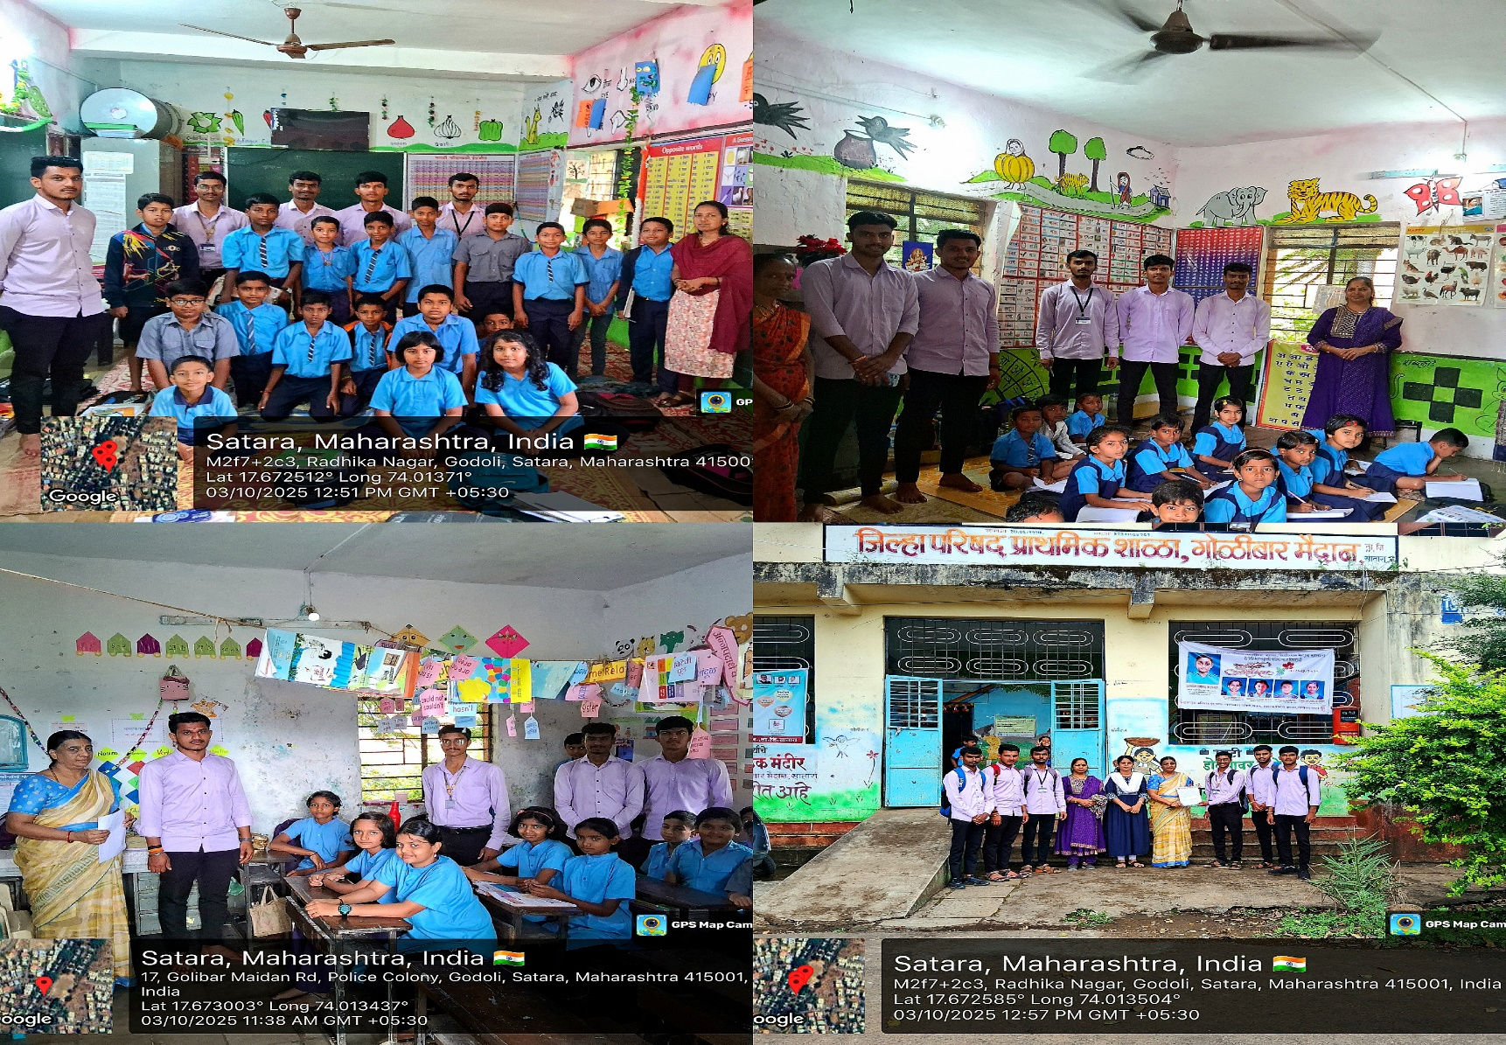
- Community engagement program photos

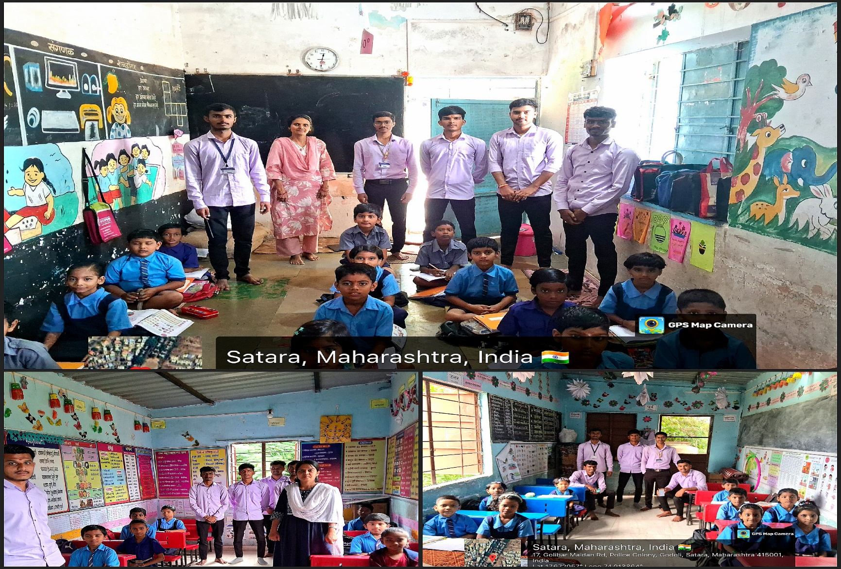
- Quetionarry

- पूर्ण नाव *
- इयत्ता *
५ वी
३ री
२ री
१ ली
४ थी
७ वी
६ वी
- वय *
- लिंग *
मुलगा
मुलगी
- उंची ( सें.मी.)
- वजन ( किलो ) *
- नाष्ट्यामध्ये जास्त करून काय खातोस/खातेस?*
पोहे
उपमा
चपाती-भाजी
अंडी
इतर
- रोज दूध पिता का?
हो
नाही
- किती वेळा अंडी/मासे/मांस खातोस/खातेस?
दररोज
महिन्यातून २-३ वेळा
क्वचितच
कधीच नाही
- तुझ्या रोजच्या जेवणात हिरवी पालेभाजी /कडधान्य किती वेळा असते ?*
नेहमी
कधीकधी
क्वचितच
- पाणी दिवसाला साधारण किती वेळा पिता?
१-४ ग्लास
५-६ ग्लास
त्यापेक्षा जास्त
- तुम्ही बाहेरचे पदार्थ खाता का ? (किती वेळा)?
रोज
आठवड्यातून २-३ वेळा
कधीतरी
अजिबात नाही
- शाळेत काय काय खाऊ मिळतो?
- रोज शाळेत मिळणारा पोषण आहार तुम्ही खाता की नाही ?
हो
नाही
- गेल्या ६ महिन्यात आजार (सर्दी, खोकला, ताप) किती वेळा झाले?*
वारंवार
कधीकधी
क्वचितच
नाही झाले
- शाळेत/घरी खेळण्यासाठी दररोज किती वेळ घालवतोस/घालवतेस?*
१ तासापेक्षा जास्त
३० मिनिटे – १ तास
खूप कमी
- तुला डॉक्टरांकडे तपासणीसाठी किती वेळा नेलं जातं?
नियमित
आजारी पडलो की
जवळजवळ कधीच नाही
- तुला दररोज साधारण किती वेळ झोप मिळते?
५ पेक्षा कमी
५-६ तास
६-८ तास
९ पेक्षा जास्त
- तुला वाटतं का की शाळेत आरोग्य तपासणी नियमित व्हावी?*
हो
नाही

